**Name: Dhananjay Narayan Kuber**

**Roll No.: 35036**

**Subject: Cloud Computing**

**Lab Assignment No. 05**

**Title: Find a procedure to launch a virtual machine using try stack (Online Open stack Demo Version)**

1. Log in to the AWS console and search for the EC2 service

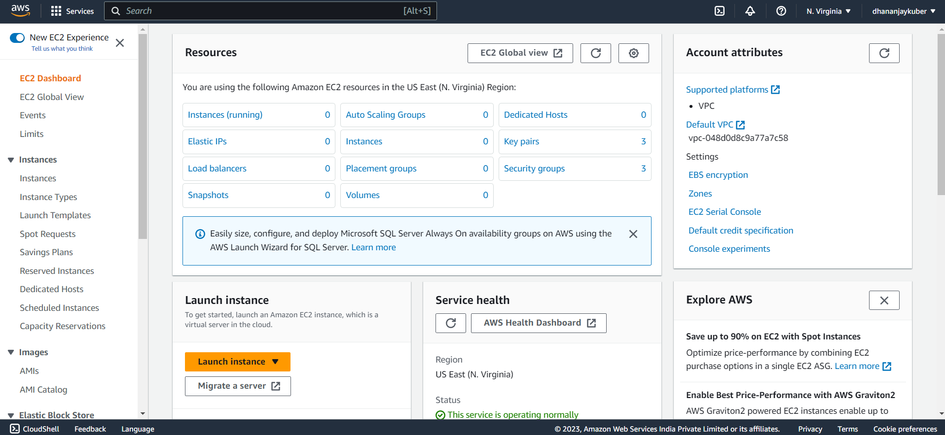

1. Go to Instance → Launch Instance
   1. Give a name to the instance
   2. Select image for machine

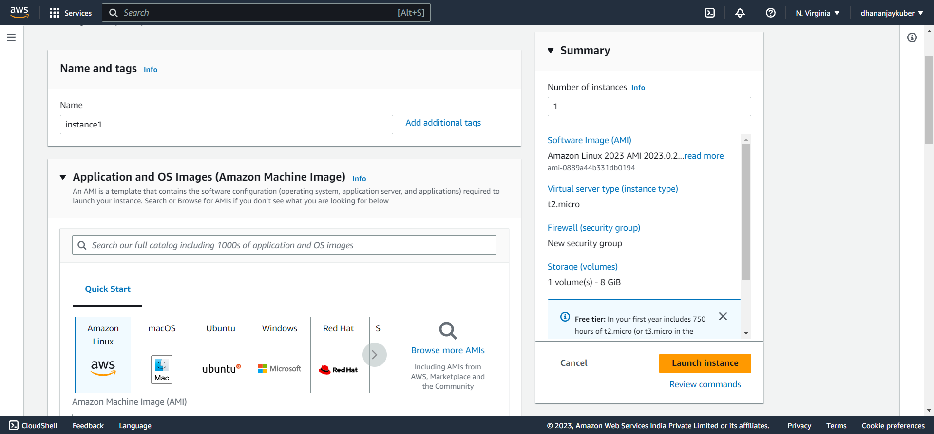

1. Create a key-pair value for instance

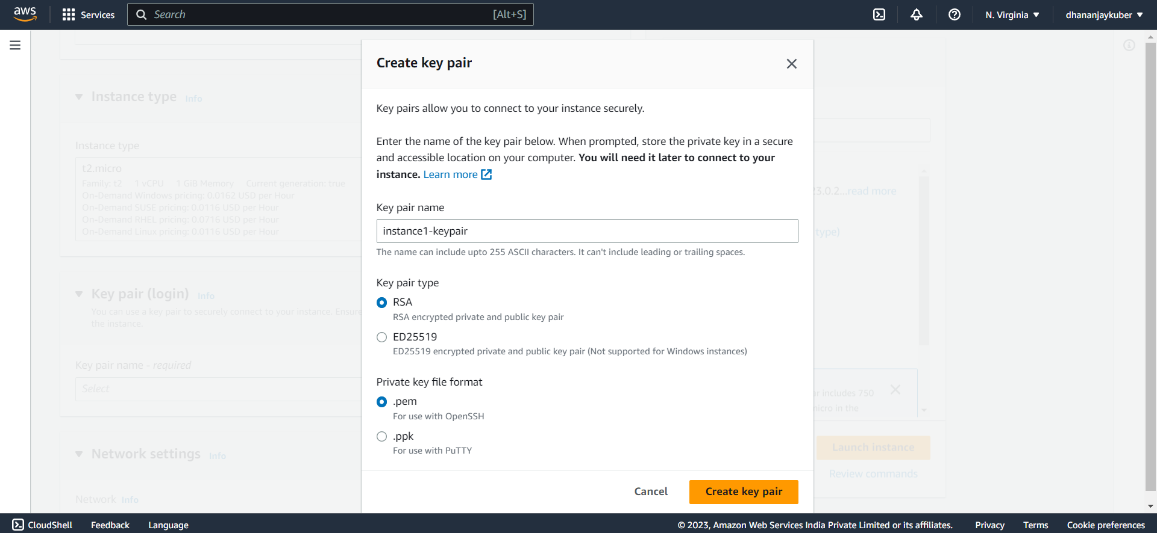

1. Launch the instance

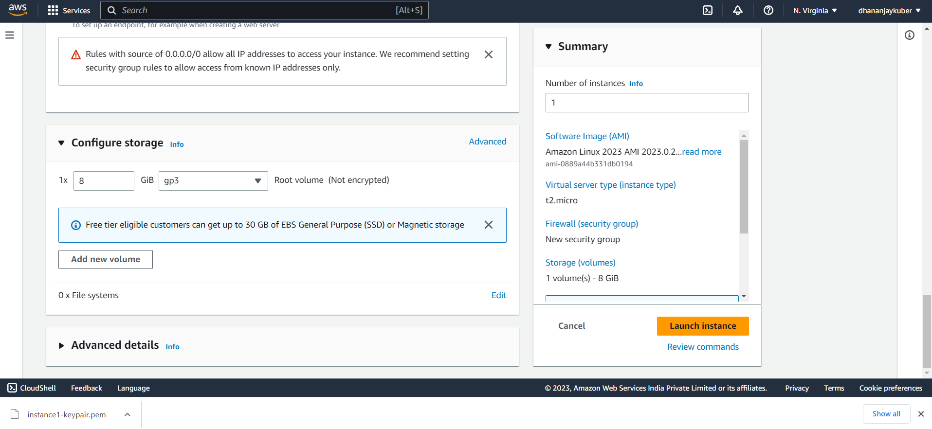

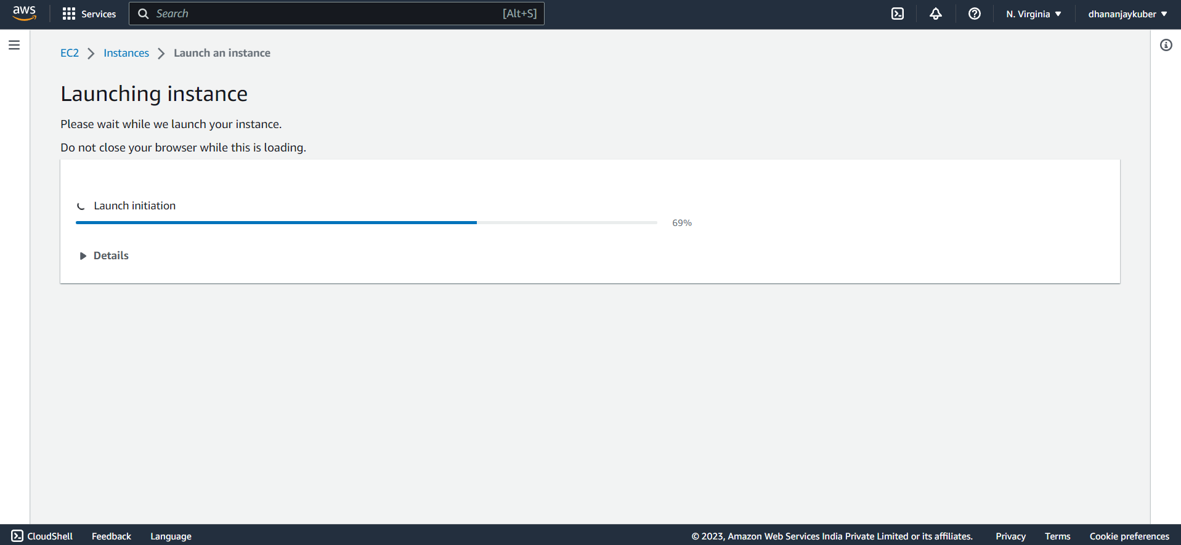

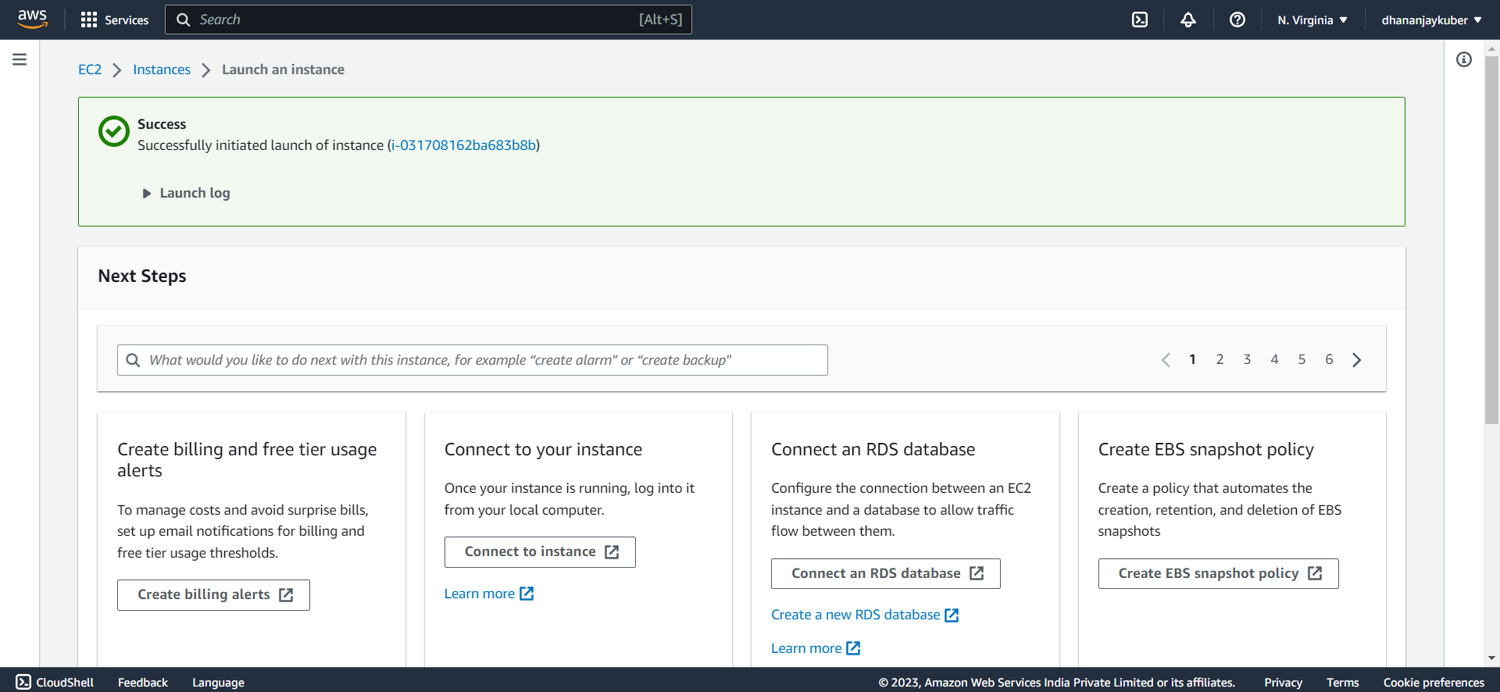

1. Check whether the instance is created or not

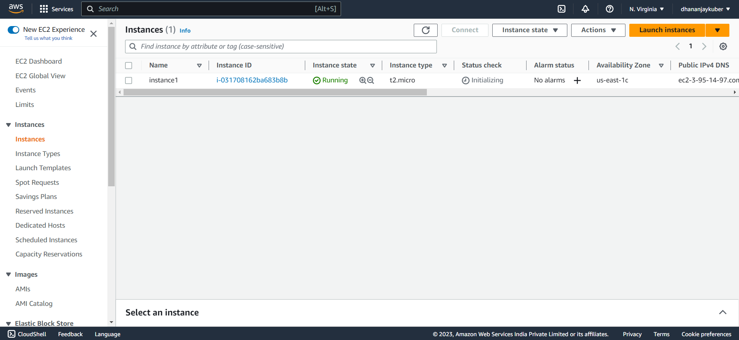

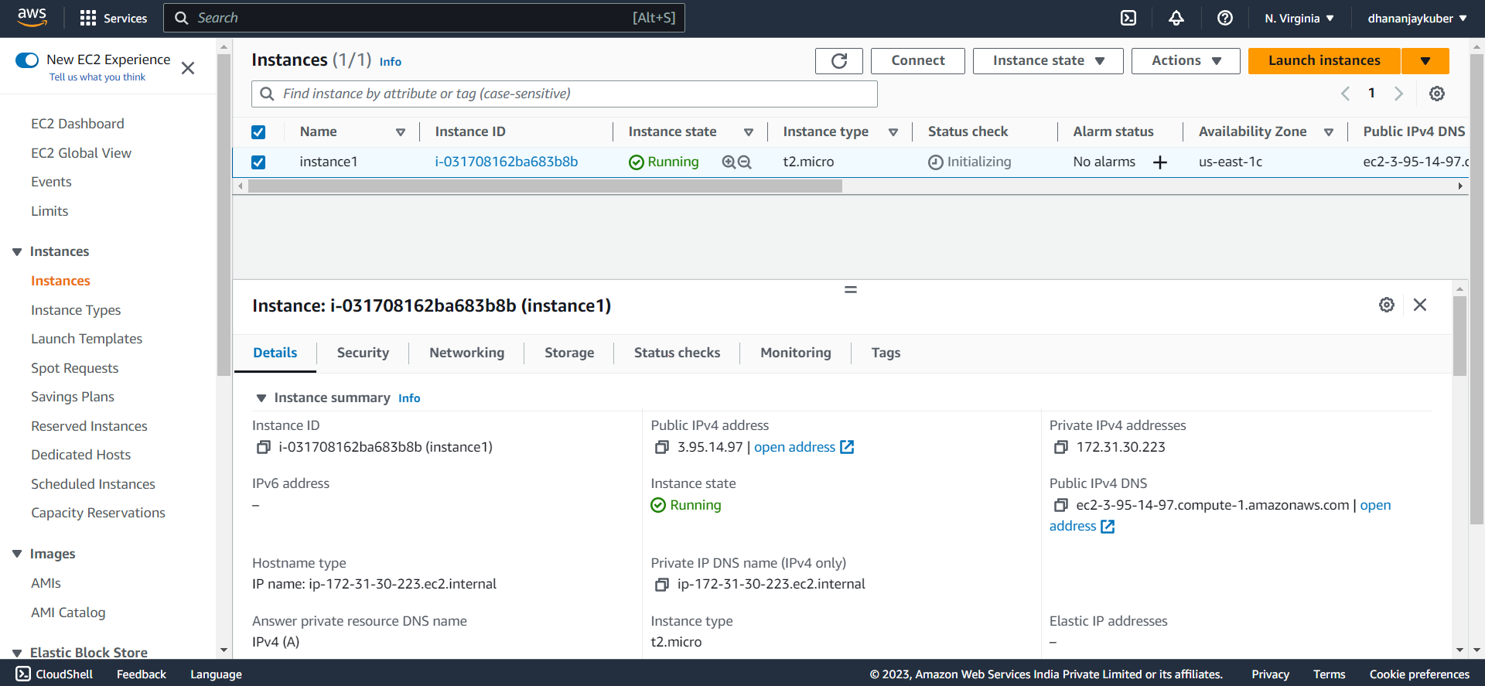

1. Go to Elastic Block Storage → Volumes

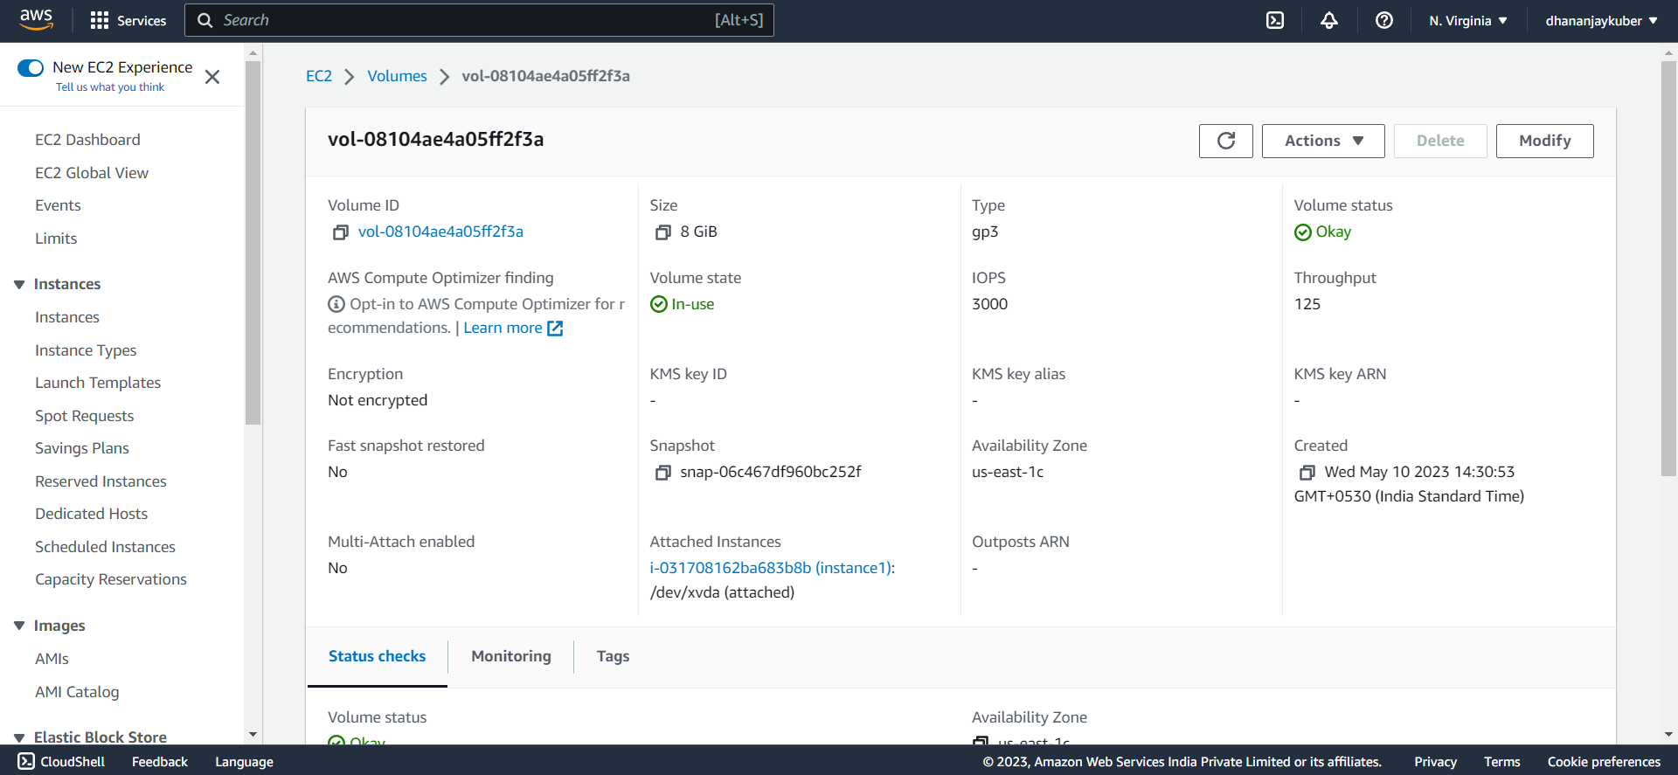

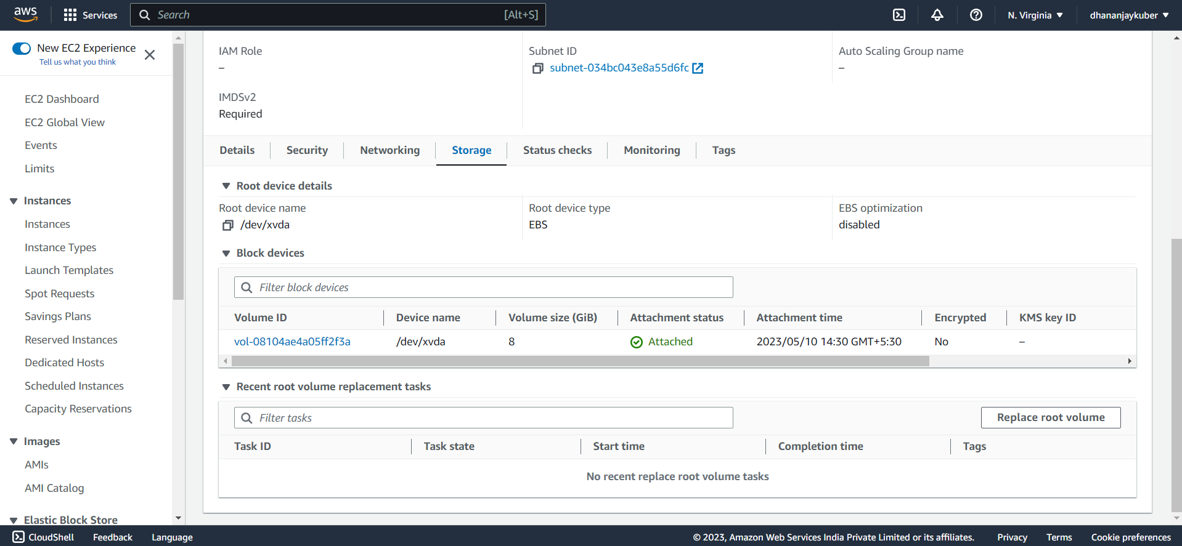

1. Connect to Instance

